**1 HTML**

**1.WHAT IS DOCTYPE?**

**IT WILL INSTRUCT TO THE BROWSER WHICH TYPE OF VERSION WE ARE USING.**

**EX:** <!DOCTYPE html>

**2.HTML4 ATTRIBUTES?**

**WIDTH**

**HEIGHT**

**HREF**

**SRC**

**ALT**

**TITLE**

**STYLE**

**LANG  
TARGET**

**3.WHAT IS HTML ATTRIBUTE?**

**ATTRIBUTE PROVIDES ADDITIONAL INFORMATION ABOUT HTML ELEMENTS.**

**4. IFRAME**

**IFRAME IS USED FOR DISPLAY WEBPAGE WITH IN THE WEBPAGE.**



**5.WHAT IS HTML ELEMENT?**

**HTML ELEMENT IS DEFINED BY “STARTING TAG”,” SOME CONTENT” AND “ENDING TAG”**

**EX:<h1>programming language</h1>**

**6.IMAGE TAG REQUIRED ATTRIBUTES**

**SRC**

**ALT**

**7.ANCHOR TAG REQUIRED ATTRIBUTES**

**HREF**

**8.AUDIO SUPPORTED FORMATS**

**MP3**

**OGG**

**WAV**

**9.VIDEO SUPPORTED FORMATS.**

**MP4**

**WEBM**

**OGG**

**10.DIFFRENCE BETWEEN BLOCK LEVEL VS INLINE ELEMENTS?**

**BLOCK LEVEL ELEMENTS ALWAYS STARTS NEW LINE.IT WILL TAKE 100% WIDTH.**

**EXAMPLE**

**DIV**

**H1-H6**

**P**

**FORM**

**HEADER**

**FOOTER**

**NAV**

**SECTION**

**INLINE ELEMENTS DOES NOT START NEW LINE. IT WILL TAKE AS MUCH WIDTH AS NECESSARY.IT WON’T TAKE WIDTH, HEIGHT, MARGIN TOP, MARGIN BOTTOM.**

**EXAMPLE**

**SPAN**

**ANCHOR**

**IMAGE**

**TEXTAREA**

**INPUT**

**LINK**

**11.EMPTY ELEMENTS IN HTML OR SELF CLOSING TAGS OR VOID ELEMENTS?**

**Empty elements doesn’t have end tag.**

**Example**

**<br>**

**<hr>**

**<img>**

**<input>**

**<link>**

**12.WHAT IS SEMANTIC ELEMENTS?**

**SEMANTIC ELEMENTS CLEARLY DESCRIBES THE MEANING BOTH BROWSER AND DEVELOPER.IT IS HELPFUL FOR SCREEN READERS.IT MAKES WEPAGES ACCESSIBLE FOR MOBILE DEVICES AND PEOPLE WITH DISABILITIES AS WELL.IT IMPROVES WEBSITE SEO(SEARCH ENGINE OPTIMIZAITON).WHICH IS THE PROCESS INCREASE THE NUMBER OF PEOPLE VISIT YOUR WEBPAGE.**

**EXAMPLE:**

**ARTICLE**

**HEADER**

**FOOTER**

**NAV**

**SECTION**

**13.DIFFERENCE BETWEEN CLASS VS ID?**

|  |  |
| --- | --- |
| **ID IS UNIQUE.** | **CLASS WE CAN USE MULTIPLE TIMES** |
| **ID IS DEFINED BY #** | **CLASS DIFINED BY DOT.** |
| **ID IS HIGH PRIORITY** | **CLASS IS LOWER PRIORITY THAN ID** |
| **ID IS USED TO POINT STYLE IN STYLESHEET AND BY JAVSCRIPT TO MANIPULATE ELEMENT WITH SPECIFIC ID.** |  |
| **ID CANNOT START WITH NUMBER AND SYMBOL** | **CLASS CANNOT START WITH NUMBER AND SYMBOL** |

**14.WHICH “IDE” YOU ARE USING OR WHICH EDITOR YOU ARE USING?**

**VISUAL STUDIO CODE**

**15.DIFFERENCE BETWEEN “HTM” VS “HTML”?**

* **BOTH ARE EXTENSION FOR THE HTML FILE.**
* **“HTM” IS MAINLY USED IN ANCIENT DAYS. WHEN THE OPERATING SYSTEMS ARE STRONG ENOUGH TO HOLD FOUR-LETTER EXTENSION.**

**16. HEADING TAGS**

**6 (H1,H2,H3,H4,H5,H6)**

**17.WHAT IS “ALT” ATTRIBUTE?**

**IF IMAGE FOR SOME REASON CANNOT BE DISPLAYED OR DUE TO SLOW CONNECTION OR ERROR IN SRC ATTRIBUTE OR IF THE USER USES SCREEN READER THAT PURPOSE WE WILL USE “ALT” ATTIRBUTE.**

**18.HTML5 NEW FEATURES**

**DOCTYPE HTML**

**SEMANTIC ELEMENTS**

**AUDIO AND VIDEO**

**CANVAS AND SVG**

**LOCAL STORAGE AND SESSION STORAGE**

**DRAG AND DROP**

**WEBWORKERS**

**SSE**

**19.WHAT IS DIFFRENCE BETWEEN STRONG VS BOLD.**

**“BOLD TAG” WE WILL USE FOR TEXT BOLD.**

**“STRONG TAG” WE WILL USE FOR IMPORTANT AND IT IS USEFUL FOR SCREEN READERS.**

**20.BROWSERS**

**CHROME**

**MOZILA**

**OPERA**

**SAFARI**

**IE**

**EDGE**

**21.HTML PAGE STRUCTURE?**

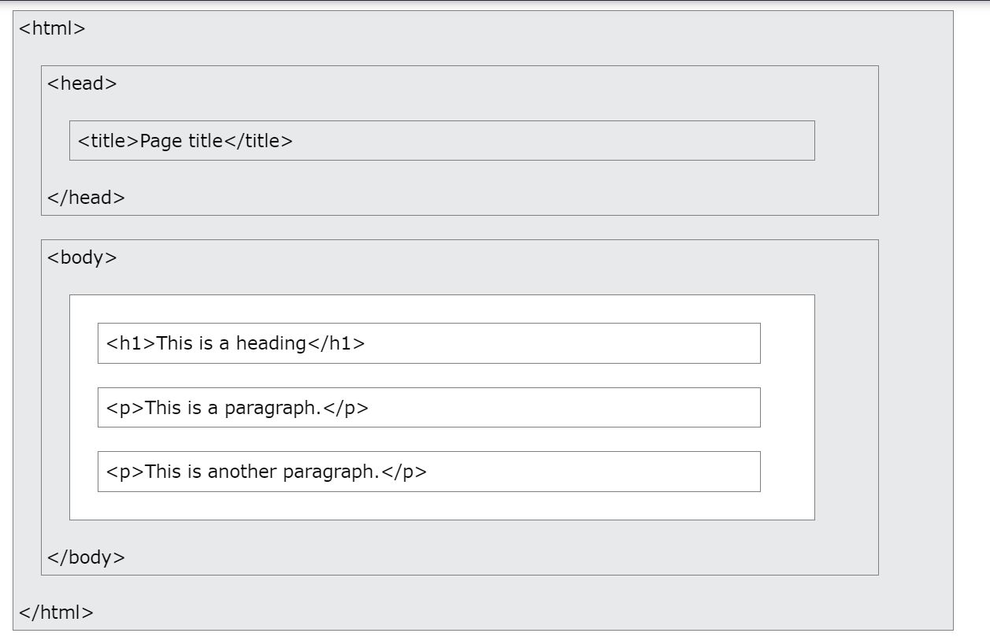

**22.DIFFERENCE BETWEEN DIV VS SPAN?**

**DIV IS BLOCKLEVEL ELEMENT.**

**SPAN IS INLINE ELEMENT**

**23.FORM ELEMENT TYPES IN HTML 5?**

**COLOR**

**DATE**

**DATETIME-LOCAL**

**EMAIL**

**TIME**

**URL**

**RANGE**

**TELEPHONE**

**NUMBER**

**SEARCH**

**24.WHAT IS MARQUEE?**

**MARQUEE IS USED FOR THE SCROLLING TEXT ON A WEB PAGE. IT SCROLLS IMAGE OR TEXT UP,DOWN,RIGHT,LEFT.**

**25.HOW MANY TYPES OF CSS CAN BE INCLUDED IN HTML?**

**INLINE**

**INTERNAL**

**EXTERNAL**

**26.WHAT IS IMAGE MAP?**

**IMAGE MAP IS USED FOR TO LINK MANY DIFFERENT WEBPAGES USING SINGLE IMAGE. IT IS USED BY <MAP> TAG.**

**27.HTML 5 API’S?**

**GEOLOCATION**

**LOCALSTORAGE AND SESSION STORAGE**

**WEBWORKERS**

**SSE**

**DRAG AND DROP**

**28. EXPLAIN LAYOUT OF HTML OR HOW TO DIVIDE PAGES?**

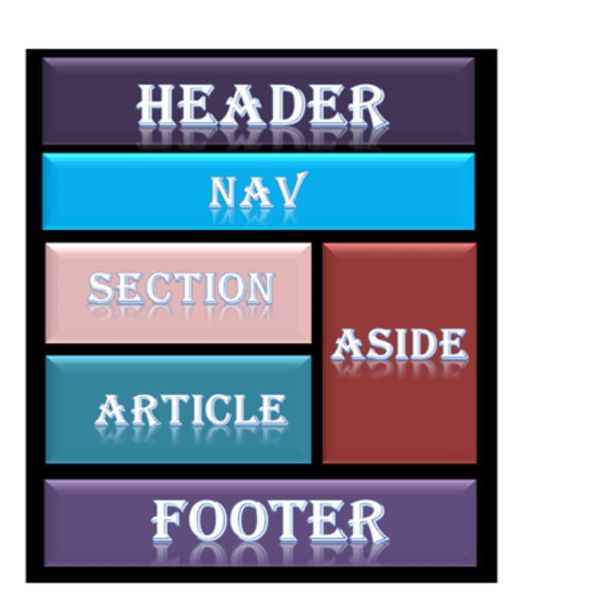

**29.LISTS IN HTML?**

**ORDERED LIST**

**UN ORDERED LIST**

**DEFINITION LIST**

**30.LOGICAL TAGS VS PHYSICAL TAG IN HTML?**

**LOGICAL TAGS ARE USED IN HTML TO DISPLAY THE TEXT ACCORDING TO LOGICAL STYLES.**

**EX:**

**<ABBR>**

**<ACRONYM>**

**<ADDRESS>**

**<DEL>**

**<PRE>**

**PHYSICAL TAGS ARE USED IN HTML TO PROVIDE PHYSICAL FORMATING TO THE TEXT.**

**EX:<B>,<BIG>,<SMALL>,<SUP>,<SUB>**

**31.DEPRECATED ELEMENTS IN HTML5?**

**<ACCRONYM>**

**<APPLET>**

**<BASEFONT>**

**<BIG>**

**<CENTER>**

**<DIR>**

**<FRAME>**

**<FRAMESET>**

**<FONT>**

**<NOFRAMES>**

**<STRIKE>**

**<TT>**

**32.WHAT IS VIEWPORT?**

**VIEWPORT IS THE USER’S VISIBLE AREA OF WEBPAGE.**

**33.WHAT IS RESPONSIVE WEB DESIGN?**

**CREATING WEBSITES WHICH AUTOMATICALLY ADJUST THEMSELVES TO LOOK GOOD ON ALL DEVICES FROM SMALLPHONES TO LARGE DESKTOPS.**

**34.IF DOCTYPE NOT MENTIONED WHAT WILL HAPPEN?**

**IF DOCUMENT TYPE IS NOT MENTIONED BROWSER WILL GO TO THE QUIRKS MODE.QUIRKS MODE DEPENDS UPON THE WEB BROWSER VERSION. IF IT IS OLDER VERSION THAN THIS WILL NOT SUPPORT HTML5 TAGS.**

**35.IN HTML WHAT YOU WILL DO FOR RESPONSIVE**

**<meta name="viewport" content="width=device-width, initial-scale=1">**

**36.DIFFRENCE BETWEEN SEMANTIC ELEMENTS VS NON-SEMANTIC ELEMENTS.**

**NON-SEMANTIC**

**NON-SEMANTIC ELEMENTS DON’T HAVE MEANING.**

**EX: DIV,SPAN**

**SEMANTIC**

**SEMANTIC ELEMENTS CLEARLY DESCRIBES THE MEANING BOTH BROWSER AND DEVELOPER.IT IS HELPFUL FOR SCREEN READERS.**

**EXAMPLE:**

**ARTICLE**

**HEADER**

**FOOTER**

**NAV**

**SECTION**

**37.WHAT IS MARKUP LANGUAGE**

**MARKUP LANGUAGE TELLS WEB BROWSERS HOW TO DISPLAY WEBPAGES WORDS AND IMAGES.**

**38. WHAT IS PICTURE TAG IN HTML**

* **THE PICTURE TAG IS USED TO GIVE FLEXBILITY TO THE WEB DEVELOPERS TO SPECIFY IMAGE RESOURCES.**
* **PICTURE TAG CONTAINS ‘SOURCE’ AND ‘IMG’ TAG.**

**39.WHAT IS META TAG IN HTML?**

* **META TAG PROVIDES A INFORMATION ABOUT HTML DOCUMENT.**
* **META DATA IS USED BY BROWSERS AND SEARCH ENGINES**
* **IT DOESN’T IMPACT PHYSICAL APPEARANCE OF THE DOCUMENT.**

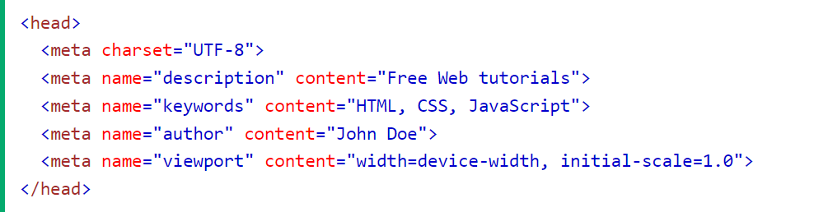

**40.WHAT IS UTF-8?**

**UTF-8 IT WILL SUPPORT ALL THE SYMBOLS IN HTML**

**EX:**

<meta charset="UTF-8">

**41.WHAT IS WEB WORKERS**

* **WHEN EXECUTING SCRIPTS IN HTML PAGE,THE PAGE BECOMES UNRESPONSIVE UNTIL THE SCRIPT IS FINISHED.**
* **WEB WORKERS IS JAVASCRIPT RUNNING IN THE BACKROUND, WITHOUT AFFECTING THE PERFORMANCE OF THE PAGE.**
* **JAVA SCRIPT DOES NOT SUPPORT MULTI THREDING AND MULTI TASKING FOR WE NEED TO IMPLEMENT MULTI THEADING USING WEB WORKES.**

**42.LOCAL STORAGE VS SESSION STORAGE**

* **“LOCAL STORAGE” THERS IS NO EXPIRATION TIME**
* **FOR SAVING DATA “localstorage.setitem(‘fname’,’html’)**
* **FOR READING DATA**

**“localstorage.getitem(fname)**

* **FOR REMOVING DATA**

**“localstorage.removeitem(‘fname’,’html’)**

* **“SESSION STORAGE” IS VALID UNTIL THE BROWSER IS OPEN ONCE BROWSER IS CLOSED THE SESSION STORAGE WILL BE CLEAN UP.**

**43.WHAT IS DIFFRENCE BETWEEN CANVAS AND SVG**

* **‘SVG’ HAS BETTER SCALABILITY IT CAN BE PRINTED HIGH QUALITY AT ANY RESOLUTION.**
* **‘CANVAS’ HAS POOR SCALABILITY IT IS NOT SUITABLE FOR PRINTING ON HIGHER RESOLUTION.**
* **‘SVG’ CAN BE MODIFIED THROUGH SCRIPT AND CSS.**
* **‘CANVAS’ CAN BE MODIFIED THROUGH SCRIPT ONLY.**
* **‘SVG’ IS NOT SUITED FOR GAMING APPLICATION**
* **‘CANVAS’ IS SUITED FOR GAMING APPLICATION.**

**44.WHAT IS GEOLOCATION**

**GEOLOCATION IS OBJECT. IT IS USED TO GET THE POSITION OF THE USER.**

**45.”TH” DEFAULT ALIGNMENT.**

**CENTER**

**46.HTML VS XHTML**

**XHTML:**

* **XML STANDS FOR EXTENSIBLE HYPERTEXT MARKUP LANGUAGE.**
* **IT IS EXTESION FOR HTML AND XML**
* **THE FORMAT IS A MARKUP LANGUAGE**
* **DOCTYPE IS VERY NECESSARY TO WRITE AT THE TOP OF THE FILE.**
* **FILENAME EXTENSION ARE .XHTML,.XHT,.XML.**

**HTML:**

* **HTML STANDS FOR HYPERTEXT MARKUP LANGUAGE**
* **IT IS EXTENDED FROM SGML**
* **THE FORMAT IS A DOCUMENT FILE FORMAT**
* **DOCTYPE IS NOT NECESSARY TO WRITE AT THE TOP**
* **FILENAME EXTENSION USED .HTML OR .HTM**

47.COOKIES

* **COOKIES ARE DATA, STORED IN TEXT FILES ON BROWSER.**
* **WHEN SERVER SENT A SEND A WEBPAGE TO BROWSER, CONNECTION IS SHUTDOWN AND SERVER FORGOT EVERYTHING ABOUT USER**
* **FOR EXAMPLE, WHEN USER VISITS A WEBPAGE, NAME CAN BE STORED IN COOKIE.**
* **NEXT TIME USER VISITS THE PAGE, COOKIE REMEMBERS NAME.**

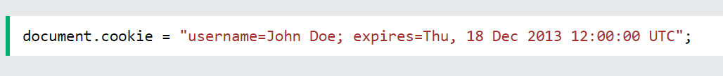

**48.WHAT IS ENTITIE IN HTML?**

**ENTITIES ARE USED DISPLAY RESERVED CHARACTERS IN HTML.**

**49.HOW TO USE IMAGE AS A LINK IN HTML?**

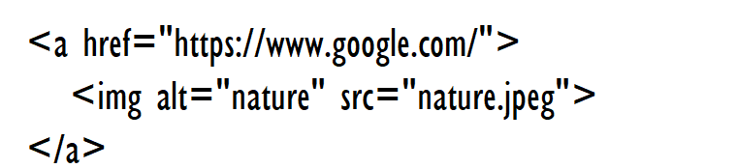

#### 50. How to insert a copyright symbol on a browser page?

#### WE CAN USE &copy or &#169 in an HTML file.

# **51. WHICH TAGS ARE USED TO DISPLAYING DATA IN TABULAR FORM IN HTML**

**USING <table> TAG.**

**52.FOR ACCESBILITY WHICH ATTRIBUTE YOU ARE USING**

**WE CAN USE ‘ARIA’ ATTRIBUTE**

**53.FORM VALIDATION WITHOUT JAVASCRIPT?**

We can use minlength

, maxlength, requried, pattern attribute.

**54.FORM TAGS IN HTML**

**INPUT**

**TEXTAREA**

**LABEL**

**FIELDSET**

**LEGEND**

**SELECT**

**OPTGROUP**

**OPTION**

**BUTTON**

**DATALIST**

**KEYGEN**

**OUTPUT**

**55.TAG VS ELEMENT IN HTML**

**TAG**

**TAGS ARE THE STARTING AND ENDING PARTS OF HTML ELEMENT.**

**ELEMENT**

**HTML ELEMENT IS DEFINED BY “STARTING TAG”,” SOME CONTENT” AND “ENDING TAG”**

**EX:<h1>programming language</h1>**

**56.FORMATING TAGS IN HTML**

**BOLD**

**STRONG**

**ITALIC**

**EMPASIZE**

**SUPERSCRIPT**

**SUBSCRIPT**

**MARKER**

**57.SELECT CHECKBOX ONCLICK ON RELATED TEXT?**

**WE USE INPUT AND LABEL ELEMENTS WITH “ID-FOR” RELATION TO ENABLE CHECKBOX.**

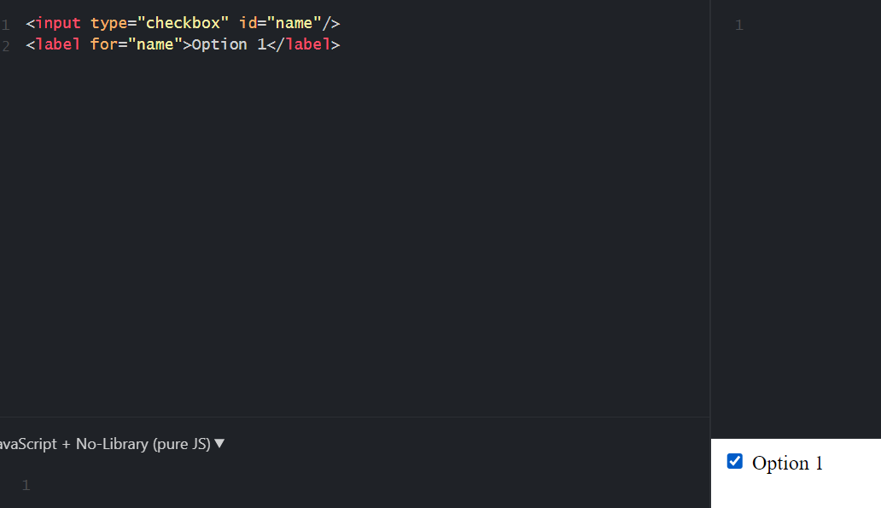

**58.WHAT ERROR WILL I GET IF I USE SAME ID FOR MULTIPLE HTML ELEMENTS?**

**JAVASCRIPT AND CSS SELECTORS WILL ONLY SELECT FIRST ELEMENT THEY FIND WITH the ID.IT IS BAD PRACTICE ID SHOULD BE UNIQUE EACH PAGE.**

**59.WHICH FORMAT DATA WILL STORE IN LOCALSTORAGE OR SESSION STORAGE.**

**DATA STORED AS KEY-VALUE PAIR.**

**60.STORAGE CAPACITY OF LOCALSTORAGE.**

**2MB TO 10MB BASED ON BROWSER**

**61.STORAGE CAPACITY OF SESSION STORAGE.**

**5MB**

**62.DRAW A CIRCLE USING CANVAS**

**D**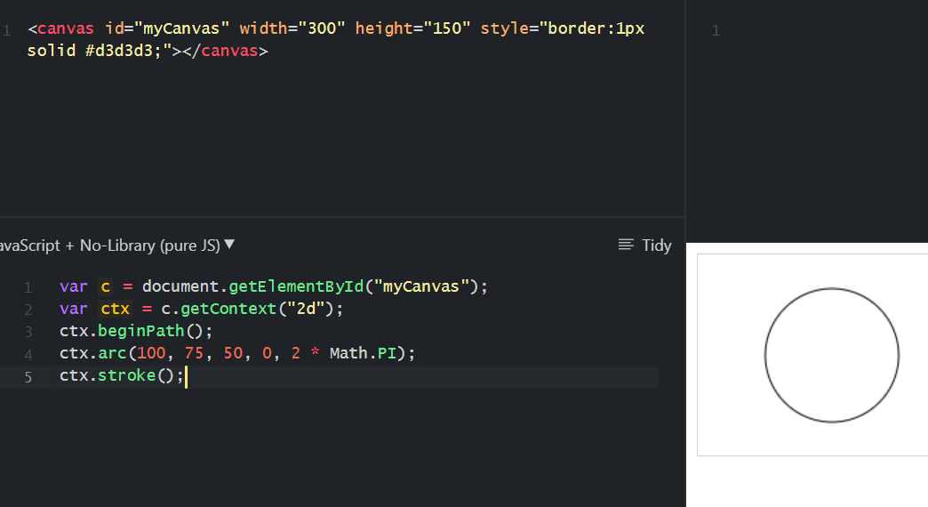

**63.**

|  |  |
| --- | --- |
| **GET** | **POST** |
| **ONLY LIMITED AMOUNT OF DATA CAN BE SENT.BECAUSE DATA SENT IN HEADER.** | **LARGE AMOUNT OF DATA CAN BE SENT.BECAUSE DATA SENT IN BODY.** |
| **GET REQUEST IS NOT SECURED BECAUSE DATA EXPOSED IN URL** | **POST REQUEST IS SECURED** |
| **GET REQUEST CAN BE BOOKMARKED** | **POST REQUEST CANNOT BE BOOKMARKED** |

**64.HTTP METHODS**

**GET**

**POST**

**PUT**

**DELETE**

**PATCH**

**65.HTML 5 NEW ATTRIBUTES**

**autofocus**

**autocomplete**

**required**

**placeholder**

**66.WHEN WILL COOKIE EXPIRE IN JAVASCRIPT.**

**WE HAVE TO SPECIFY EXPIRE DATE.**



**67.DEFAULT DISPLAY VALUE FOR HTML ELEMENT?**

**BLOCK OR INLINE**

**68.WHAT IS BEM.**

* **BEM MEANS BLOCK,ELEMENT,MODIFIER.BEM MAKES DEVELOPMENT EASY AND FAST EVEN COMPLEX UI.IT ALLOWS REUSE OF EXISTING CODE.**
* **ELEMENT NAME SEPARATED FROM BLOCK NAME WITH DOUBLE UNDERSCORE**
* **MODIFIER NAME SEPARATED FROM BLOCK OR ELEMENT NAME BY SINGLE UNDERSCORE**

**69.HOW TO DISPLAY IMAGE IN BROWSER.**

**USING “IMG”,” PICTURE”,”MAP” TAG.**

**70.HOW TO CREATE BOOKMARKS**

* **USE THE “ID” ATTRIBUTE TO DEFINE BOOKMARKS IN**

**PAGE.**

* **USE THE HREF ATTRIBUTE TO LINK THE BOOKMARK.**

**71.WHAT ALL TAGS WRITE WITH IN HEAD TAG?**

**SCRIPT**

**LINK**

**STYLE**

**META**

**TITLE**

**72.HREF FULL FORM.**

**HYPERTEXT REFERENCE**

**73.URL FULL FORM.**

**UNIFORM RESOURCE LOCATOR.**

**74.WEBWORKERS LIMITATIONS**

* **WEBWORKERS CANNOT DIRECTLY MANIPULATE THE DOM.**
* **WEBWORKERS CANNOT BE RUN DIRECTLY FROM FILE SYSTEM.IT CAN ONLY RUN VIA SERVER.**

**75.FIELD SET AND LEGEND.**

**“FIELDSET” IS USED TO GROUP OF RELATED ELEMENTS.**

**“LEGEND” TAG IS USED TO DEFINE THE TITLE FOR FIELDSET ELEMENT.**

**76.AUTOCOMPLETE**

**WHEN USER STARTS TO TYPE IN FIELD,THE BROWSER SHOULD DISPLAY OPTIONS TO FILL IN THE FIELD.BASED ON EARLIER TYPED VALUES.**

**77.OPTGROUP**

**“OPTGROUP” TAG IS USED TO GROUP RELATED OPTIONS IN “SELECT” ELEMENT.**

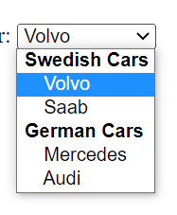

**78.TARGET=” _BLANK”**

**TARGET=”_BLANK” TELLS THE BROWSER TO OPEN THE LINK IN NEW WINDOW.**

**79.”contenteditable” ATTRIBUTE**

**“contenteditable” attribute specifies content is editable or not.**